CAPSTONE PROJECT REPORT
Title:
Web Application Penetration Testing & Incident Response on DVWA

1. Executive Summary
This project focuses on identifying and analyzing security vulnerabilities in a deliberately vulnerable web application, DVWA (Damn Vulnerable Web Application).
The objective was to simulate real-world web attacks, understand their impact, and propose mitigation strategies.
Multiple vulnerabilities such as SQL Injection, Cross-Site Scripting (XSS), and File Inclusion were successfully exploited.
An incident response process was also simulated to demonstrate detection, containment, and recovery mechanisms.

2. Objective
- Identify vulnerabilities in a web application
- Perform controlled exploitation
- Analyze risks and impacts
- Suggest mitigation techniques
- Simulate incident response

3. Scope
- Target: DVWA running on localhost
- Environment: Kali Linux
- Testing Type: Controlled penetration testing
- No external systems involved

4. Tools Used
- Kali Linux
- Web Browser
- DVWA
- Nmap

5. Methodology
The project followed a structured penetration testing approach:
Step 1: Reconnaissance
- Accessed DVWA application
- Identified available modules
Step 2: Scanning
- Used Nmap to identify services
nmap -sV localhost

Step 3: Exploitation
Performed attacks on vulnerable modules:
- SQL Injection
- Cross-Site Scripting (XSS)
- File Inclusion

Step 4: Documentation
- Captured screenshots
- Recorded outputs
- Analyzed vulnerabilities

6. Vulnerability Findings

6.1 SQL Injection
Input Used:
' OR '1'='1
Description:
The application does not validate user input properly, allowing attackers to manipulate database queries.
Impact:
- Unauthorized access to database
- Exposure of sensitive data
Screenshot:
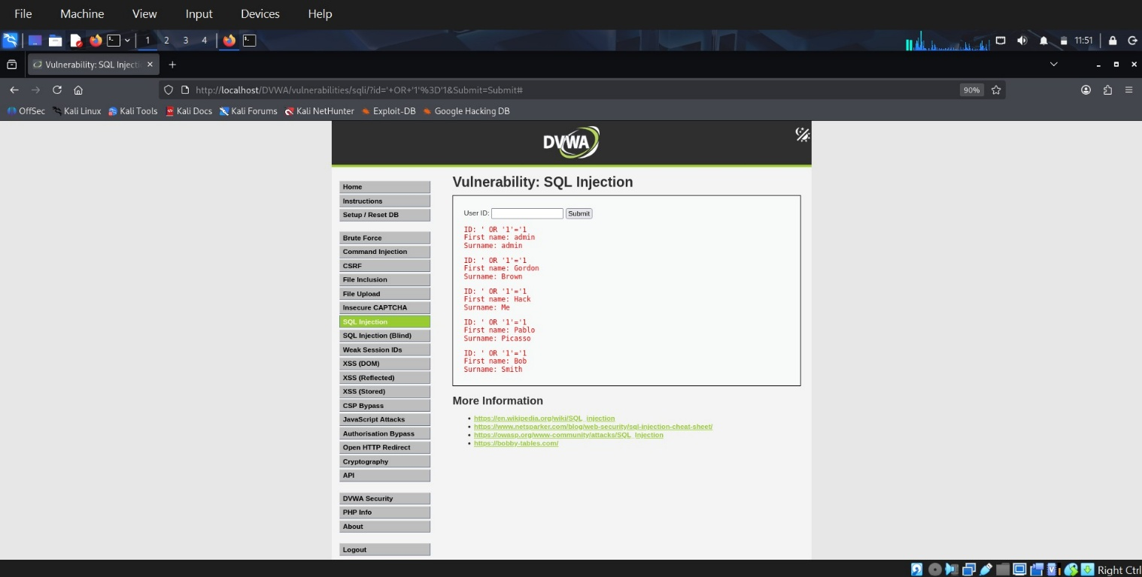
Mitigation:
- Use prepared statements
- Validate user input
- Use parameterized queries

6.2 Cross-Site Scripting (XSS)
Input Used:
<script>alert('XSS')</script>
Description:
User input is directly rendered without sanitization, allowing execution of malicious scripts.
Impact:
- Session hijacking
- Data theft
- Malicious redirection
Screenshot:
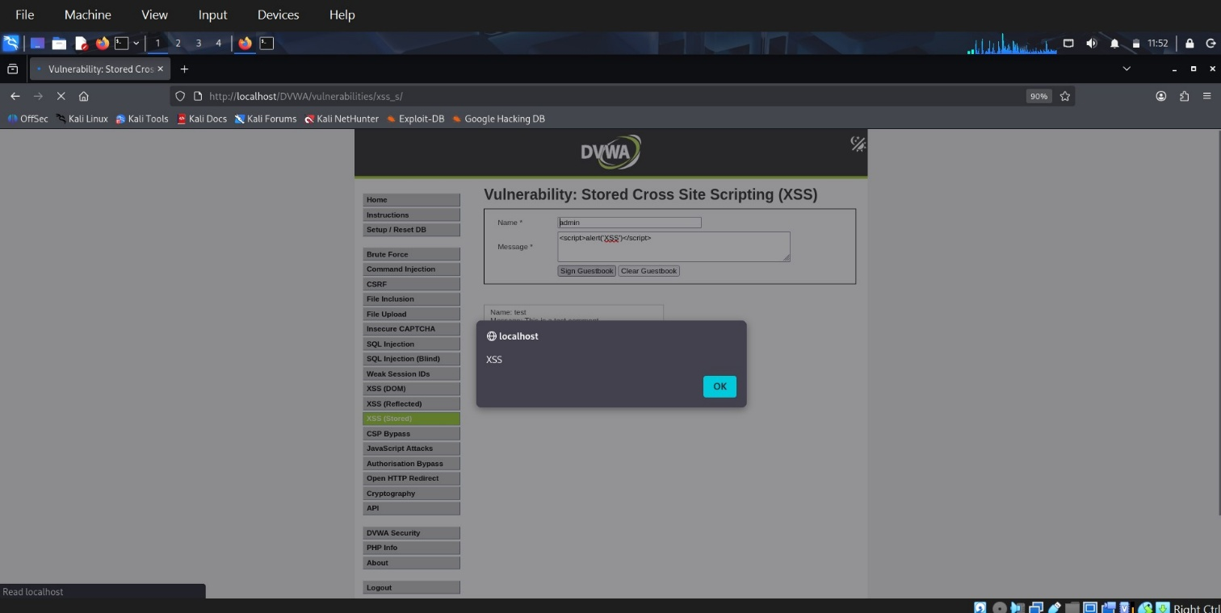
Mitigation:
- Input sanitization
- Output encoding
- Use Content Security Policy (CSP)

6.3 File Inclusion
Payload Used:
../../../../etc/passwd
Description:
Application allows inclusion of local system files without validation.
Impact:
- Access to sensitive system files
- Information disclosure

Screenshot:
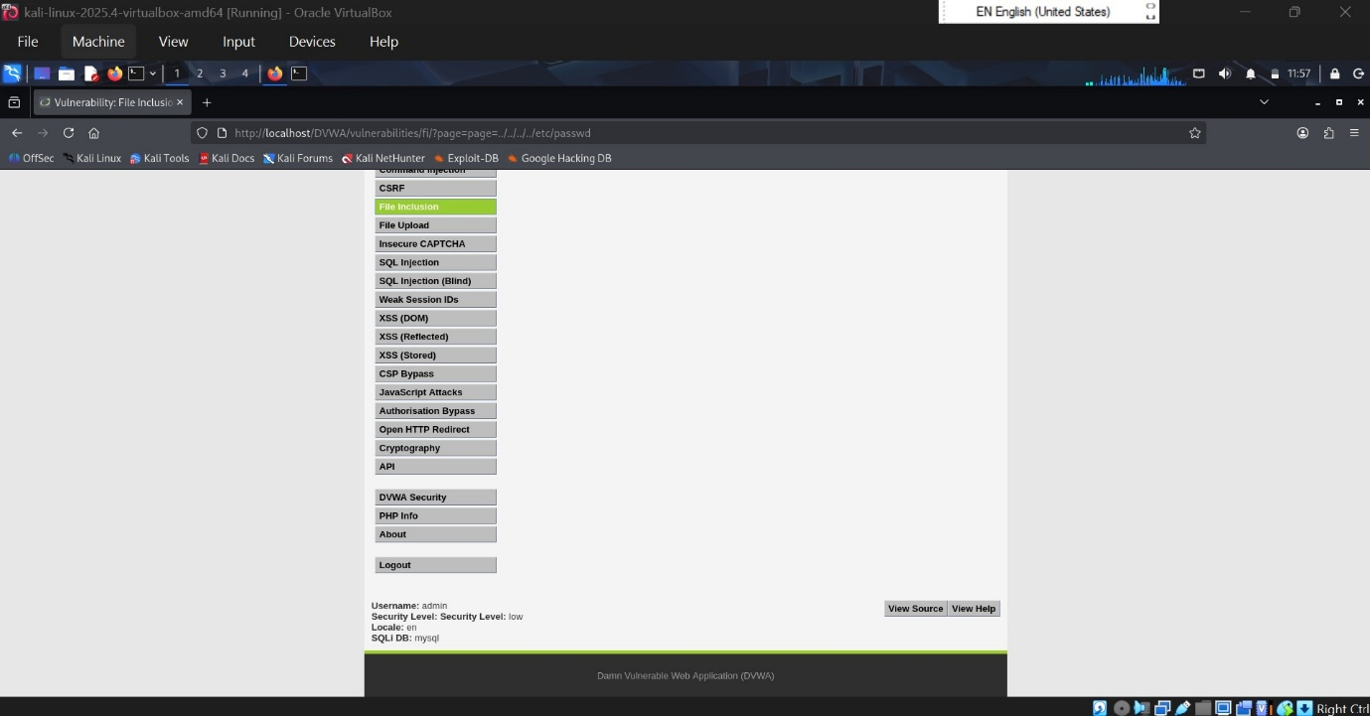
Mitigation:
- Restrict file access
- Validate file paths
- Use whitelist approach

7. Incident Response Simulation

Detection
- Suspicious inputs detected (SQLi, XSS payloads)
- Abnormal application behaviour observed

Containment
- Block malicious inputs
- Restrict user access

Eradication
- Fix vulnerable code
- Implement input validation

Recovery
- Restart application
- Verify system integrity

Lessons Learned
- Importance of secure coding
- Need for regular security testing
- Monitoring and logging is essential

8. Results
- Successfully identified multiple vulnerabilities
- Demonstrated real-world attack scenarios
- Understood system weaknesses
- Proposed effective mitigation strategies

9. Conclusion
This project demonstrated how insecure web applications can be easily exploited if proper security measures are not implemented.
It highlights the importance of secure coding practices, regular testing, and proper incident response mechanisms.
Understanding these vulnerabilities helps in building more secure and resilient systems.

10. References
- DVWA Documentation
- OWASP Top 10
- Nmap Documentation

